User’s Manual
AOT-MD-500A

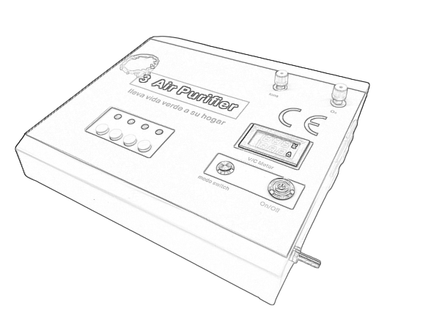

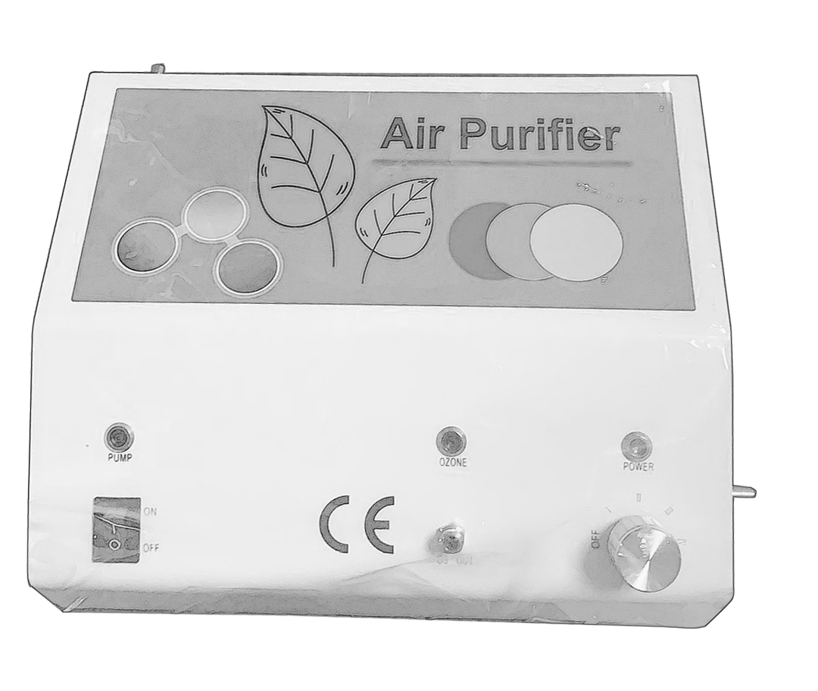

Table of Content

FOzone Introduction ……………………………………1
FFeatures and Specification ……………………………1
FStructure and Accessories …………………………… 2
FInstallation and Usage ……………………………… 3
FApplication ……………………………………………3
FSafety and Cautions ………………………………… 5
FFAQ ……………………………………………………5
FMaintenance Service …………………………………6
FWarranty card …………………………………………6

I、 Ozone Introduction
Ozone, O3, is a molecule that consists of three negatively charged oxygen atoms and is a normal constituent of the earth’s atmosphere. Ozone is produced deliberately for a variety of industrial purposes and hourhold cleaning purposes, and is also produced naturally from oxygen whenever ultra-violet radiation or electrical discharges occur, e.g. at high altitudes or by the action of lightning. Ozone itself is a distinctly blue coloured gas (bp – 111.9ºC) and is about one and a half times heavier than air (density 2.144g/l). Ozone is used as “ozone air”, a colourless gas produced when ozone is generated from part of the oxygen in air. Ozone cannot be stored or transported in vessels because it falls back into its original form (oxygen) after a while.

II、 Features and Specification

Feature
The model AOT-MOP-4 is a new air ozone generator that designed for multi-treatments with high grade ozone gas. It uses the 99.9% pure Quartz and Titanium electrodes to make pure oxygen/ozone mixed gas in high accuracy of ozone concentrations. There are 4 switches are available, and it can deliver pure ozone from low to high concentrations for different applications. Speically, it has been built-in both the powerful ozone destructor and the strong vaccum pump inside, which can remove extra ozone gas quickly at >8.5 L/min, and makes the machine very convenient to use.

Specification
Model No. | AOT-MD-500A
Ozone Concentrations: | xxx ug/mL （ 1 ug/mL = 1 gamma = 1 mg/L ）
Ozone Module | 99.9% pure Quartz and Titanium Electrode
Cooling System | 4000 RPM , brushless cooling fan
Ozone Destructor | Powerful catalyst
Life | > 10,000 hours
Pump | 8.5 L/min sucking pump
Input Voltage | 12V DC (100-240V AC to 12V DC adaptor)
Rated Power | < 14 W
Operating Temperature | -10℃ ~ 40℃
Storage Temperature | -20℃ ~ 70℃
Product Size(L x W x H) | 251*198*89 mm
Package Box Size(L x W x H) | 340 *250*160 mm
Weight | 2.35 kg
Accessories | 1pc Adapter (100-240V AC input, 12V DC output); 1pc 3 way connector; 3pcs male luer connectors; 1pc silicon tubing,2pc Stone bubbler

III、 Structure & Accessories

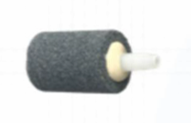
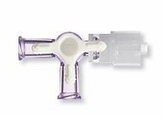
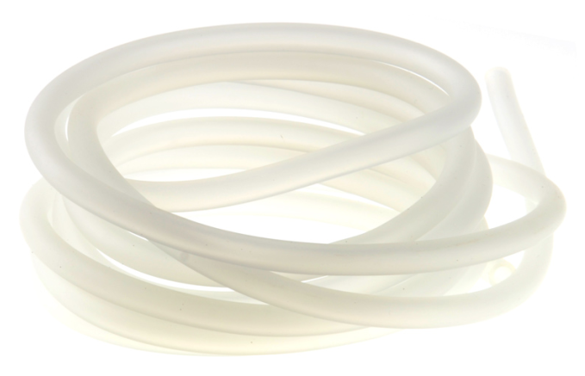
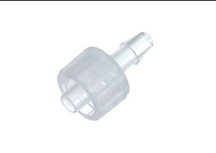
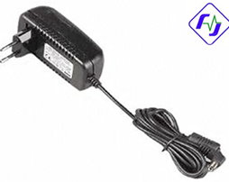

1pc * Power Adaptor
/ 1pc * 3 way connector / 3pcs * male luer connector / 1.5 meter * silicon tubing / 2pcs*stone bubbler

IV、 Installation and Usage

- Take out the appliance and accessories from the package, put it on a flat ground in which space you are going to run the appliance
- Connect the air source to the air Input connector
- Connect the 3 way connector to the Ozone Outlet
- Cut a short piece of silicon tubing, add two male luer lock connectors to each end, then connect the side outlet of 3 way connector to the Ozone Destructor (O3 Destructor）
- Adjust the 3 way connector, make sure the gas flow is from the Ozone Outlet (O3 OUT) to the Ozone Destructor inlet (O3 Destructor) before switch on the applicance.
- Connect the direct outlet of 3 way connector to the syringe or ozone bags, etc.
- Plug in the 12V DC power adaptor to the Mains and the appliance. The “POWER” indication light is red when the power is connected successfully.
- Switch the Knob Switch to the level you need. The “OZONE” indication light is green when the appliance is working.
- Open the air source, and adjust the air flow rate to get the ozone concentration according to the Ozone Concentration Table.
- Adjust the 3 way connector, make the gas flow to air , etc.
- After collecting the ozone, adjust the 3 way connector, make the gas flow back to the Ozone Destructor (O3 Destructor) again.
- Switch the Knob Switch and turn the appliance off.
- Close the air source
- Unplug the appliance.

V、 Applications
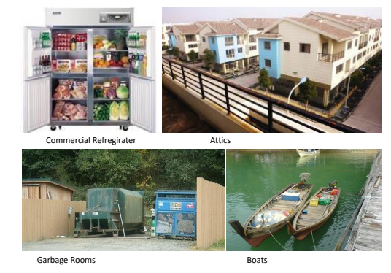

VI、 Safety and Cautions
  - Make sure that all accessories are attached in the box and the appliance is in good condition when it is received. Always keep the appliance vertical on the flat ground.
  - Do not store the appliance in a humid place.
  - Do not clean this appliance using a damp cloth when it is working
  - Operate the appliance in a precondition within 0℃ ~ 40℃ & 0 ~ 70% RH
  - Do dis-connect the adapter before opening the product or any maintenance.
  - It is not recommended to switch on & off frequently on this appliance. To avoid any defective, please re-switch on the appliance at least 2mins after switching off.
  - Do not block the ventilated fan and outlet of the appliance all the time.
  - Turn off this appliance and unplug the adapter immediately when there is ozone leakage inside the housing. A space with ventilation is preferable to stay when this happens.
  - It is not preferable to operate the appliance in flammable or explosive places. Do be more careful if it is necessary.
  - Do not allow water go into the appliance.
  - Pack the appliance into a box if it is not going to use for a long while

VII、 FAQ

Queries | Answers
Power indication light doesn’t work after plugging the adapter to the mains power socket | - if the adapter is well connected to the appliance or not  - if the indication light of the adapter on or off  - if the adapter is in good condition or not  - unplug the adapter and open the appliance, check if the wire of power connector is in good condition or not  - ask for help from whom is responsible for
No ozone comes out when the appliance is on, and the power and ozone indication light is on as well | - if the air source has been connected and be offered to make ozone  - the fan is working or not  - unplug the adapter and open the appliance, check if the connection inside is in good condition or not  - if the quartz tube of the ozone generator module is broken or not  - change the ozone generator module or ask for help from whom is responsible for.
The ozone smell is very strong around the appliance | - If the ozone outlet connectors are connected well  - If the ozone destructor be connected properly  - If the ozone destructor need replacements
Who is allowed to operate the appliance | People who are trained or with relative knowledge of ozone appliance is allowed to operate or repair it

VIII、 Maintenance Service

- This MINI Air Ozone Generator is warranted to be free from all defects in material in normal ozone use for a period of (1) year from date of purchase.
- The warranty is guaranteed only to the original purchaser and members of his or her immediate household. The warranty is subject to the following provisions. Any damages or malfunctions caused by negligence, abuse, or not operate in accordance with the User’s Manual are not covered by this warranty. Also, any defects or damages caused by unauthorized service or the use of other than Genuine parts are not covered.
- AQUAPURE will, at its option, repair or replace a defective ozone generator or part(s) for the unit that is covered by this warranty. As a matter of warranty policy, AQUAPURE will not refund the customer’s purchasing price. Please recorder the following Warranty Card when you purchase the unit from our company or the distributor.
- To obtain warranty service you must return the defective ozone generator or its parts along with proof of purchasing to our company or any Authorized Warranty Station. All transportation charges on parts, or units, submitted under this Warranty shall be borne by purchaser.

IX、 Warrenty card

Customer Name |  | Model No.
Purchase Date |  | Serial No.
Customer Address
Customer Phone

